Follow Up Details to RFP for Brunswick Meadows Kids Parks

Richard Tesmer, Treasurer
Brunswick Meadows HOA
Richard.tesmer@brunswickmeadowshoa.com
(346) 543-2721

There are only four kids' parks and one open area that is supposed to be a dog park. We will leave that alone for now.

Due to the odd shapes, I can’t provide exact measurements for the replacement of the mulch.

Park #4, Grahamwood Lane.
Kids' Climbing Wall may need to be replaced totally, both benches are in bad shape as well.

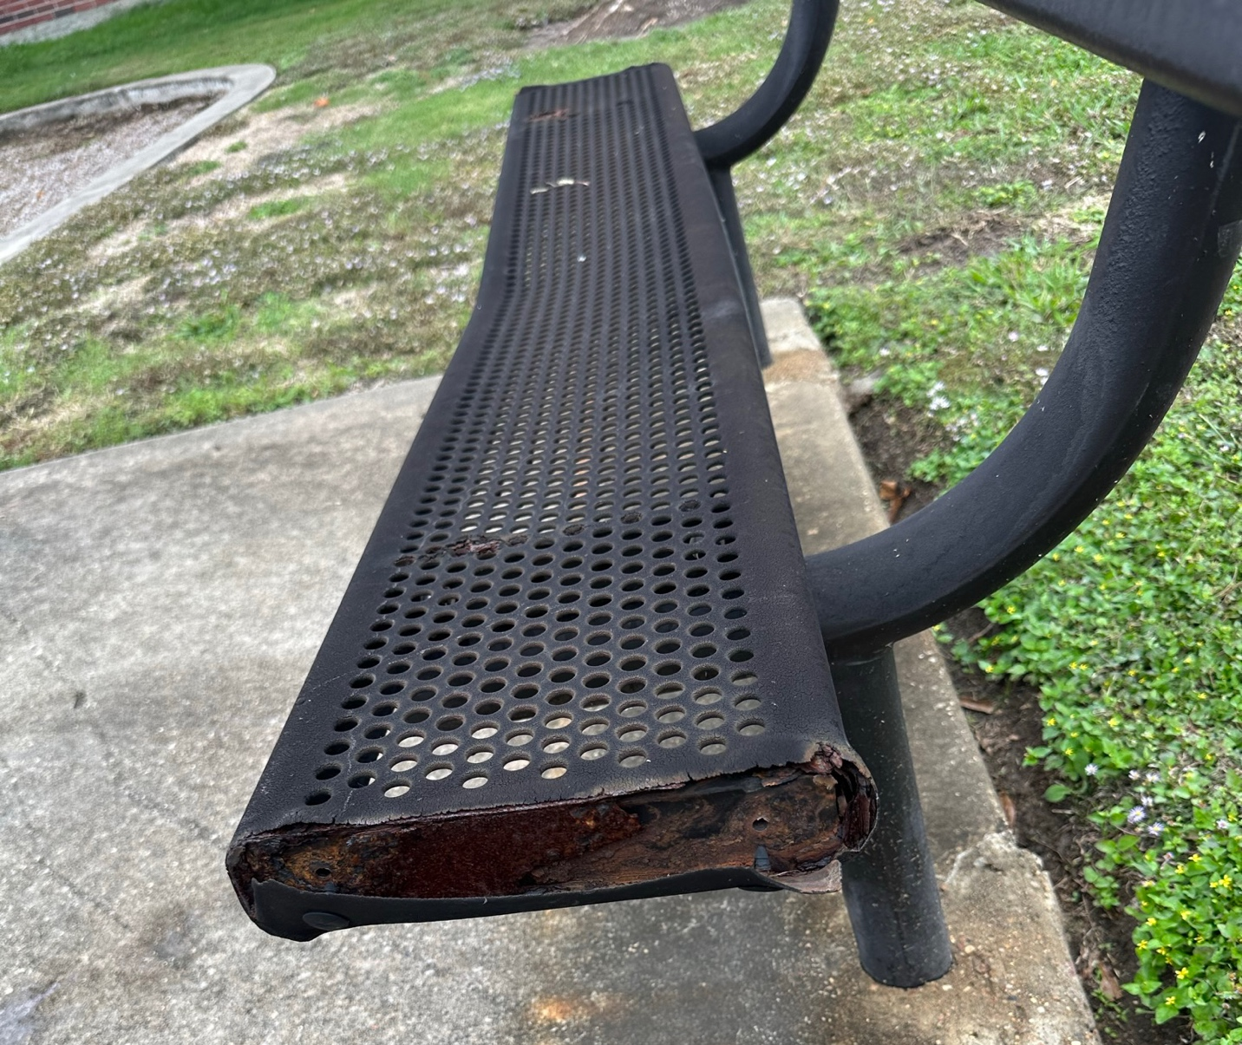

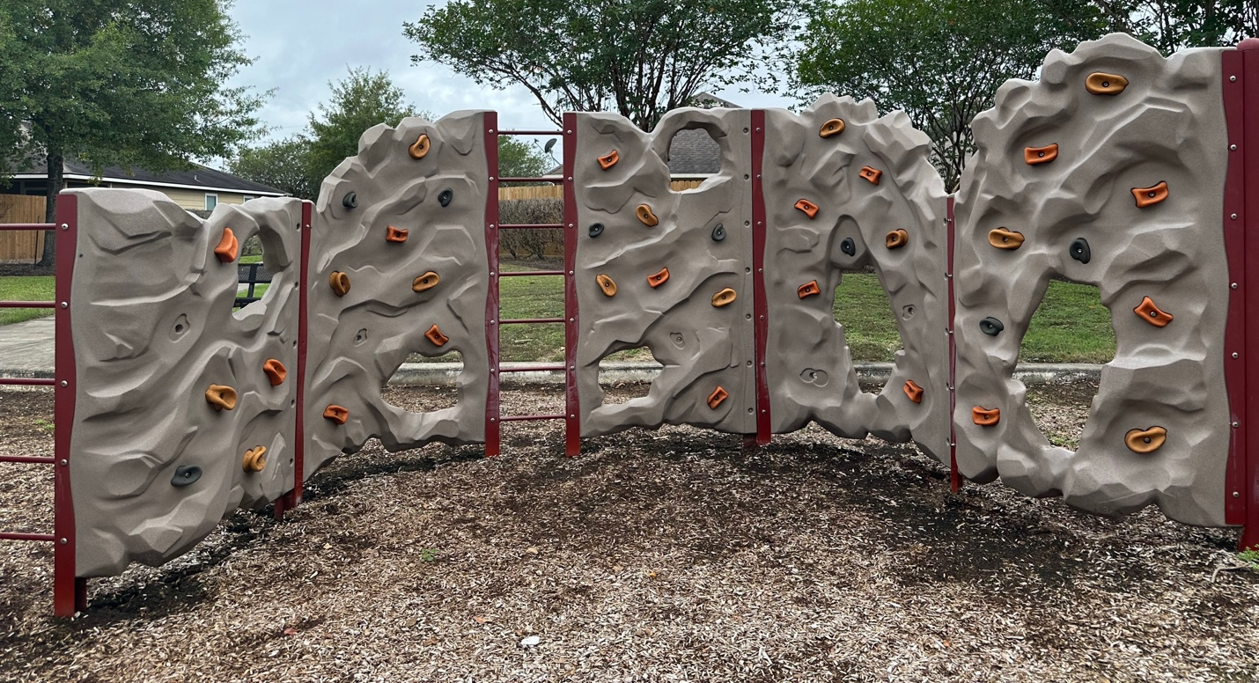

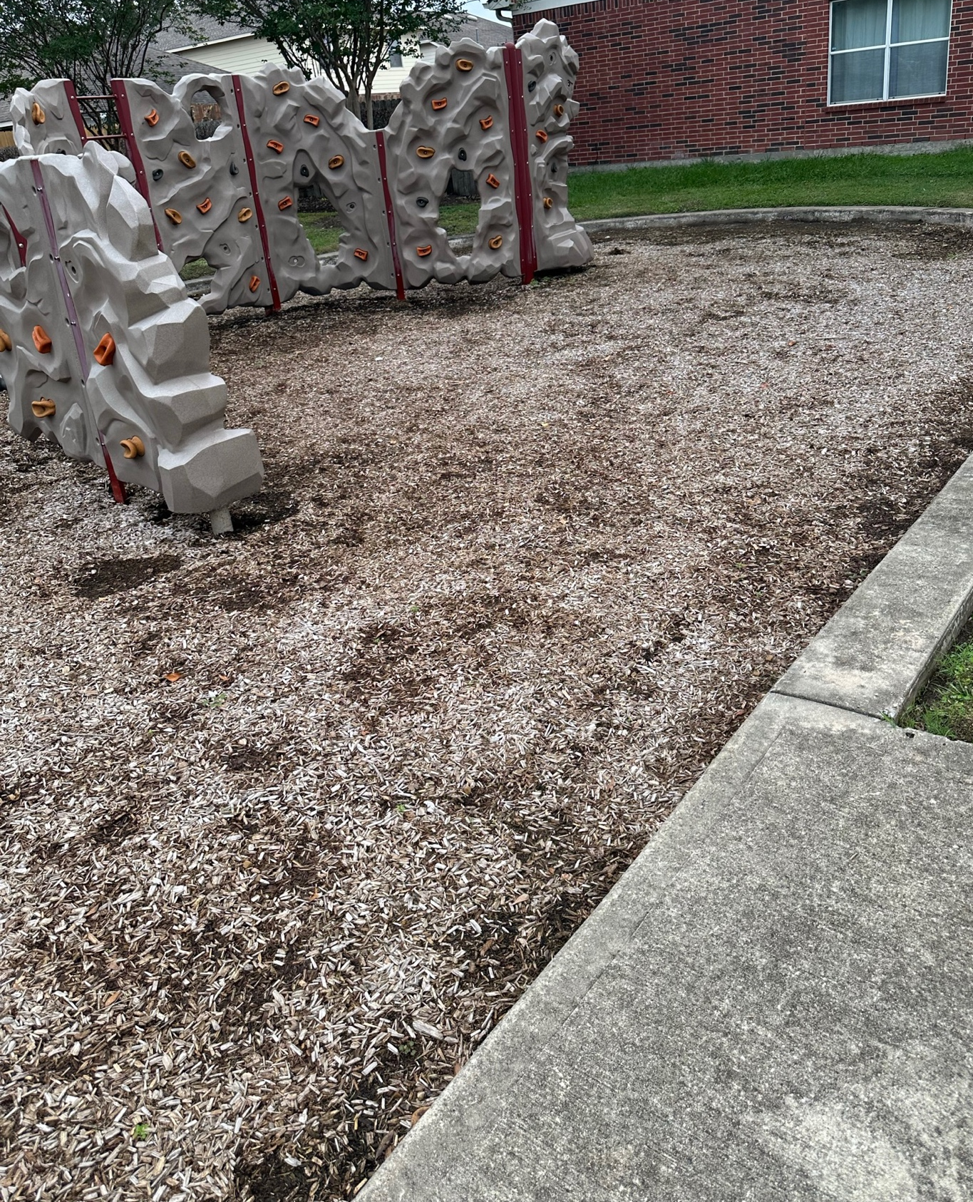

Park #2, Field Manor Lane
Kind of boring and a wasted space.

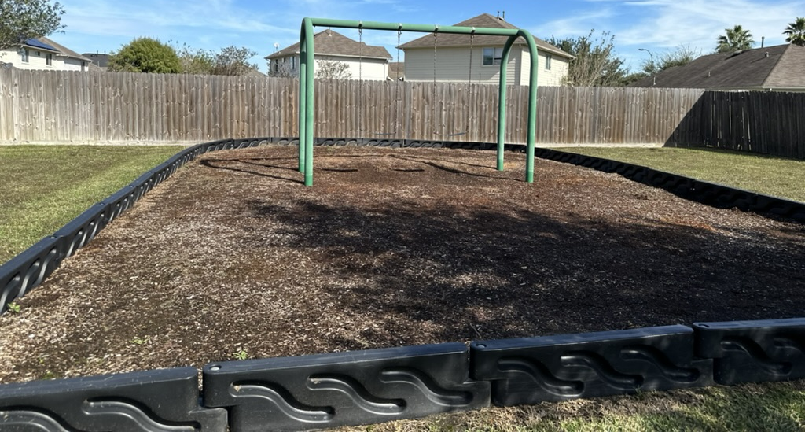

Park #3 Brunswick Meadows Lane (coming in off of the Scott entrance)

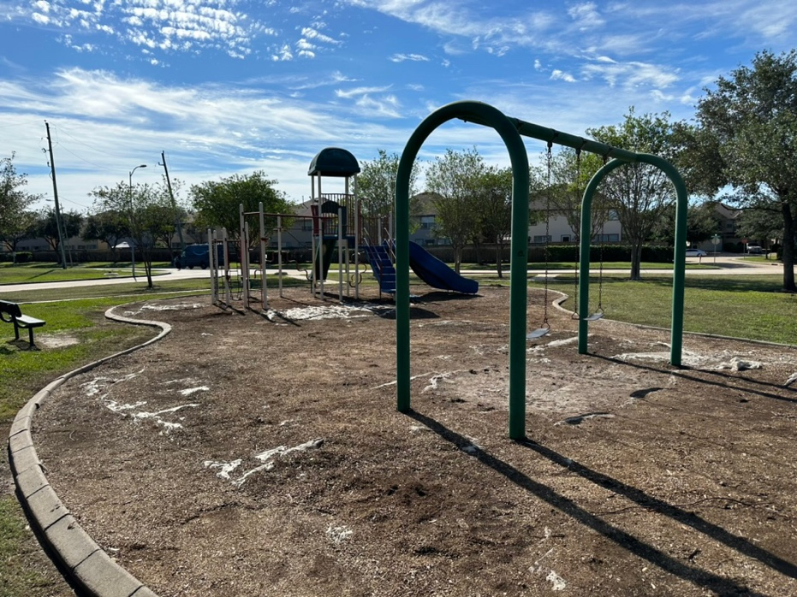

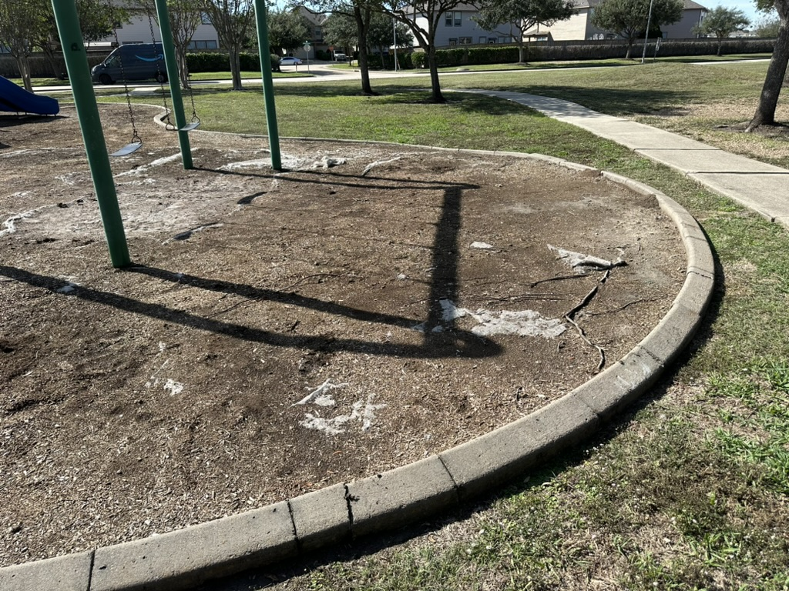

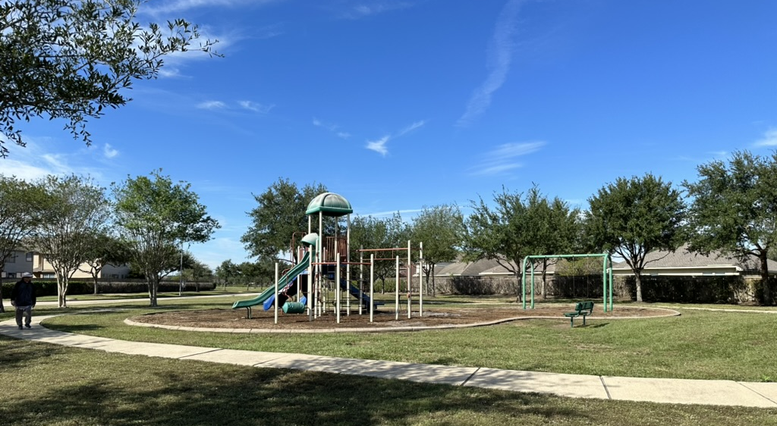

Sidewalk issues:

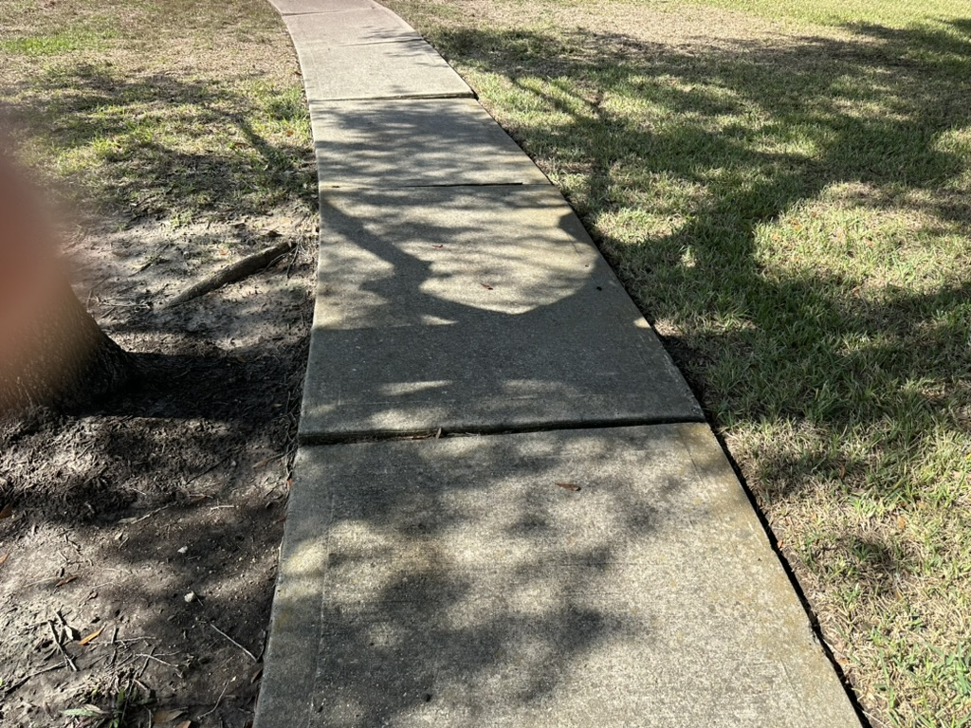

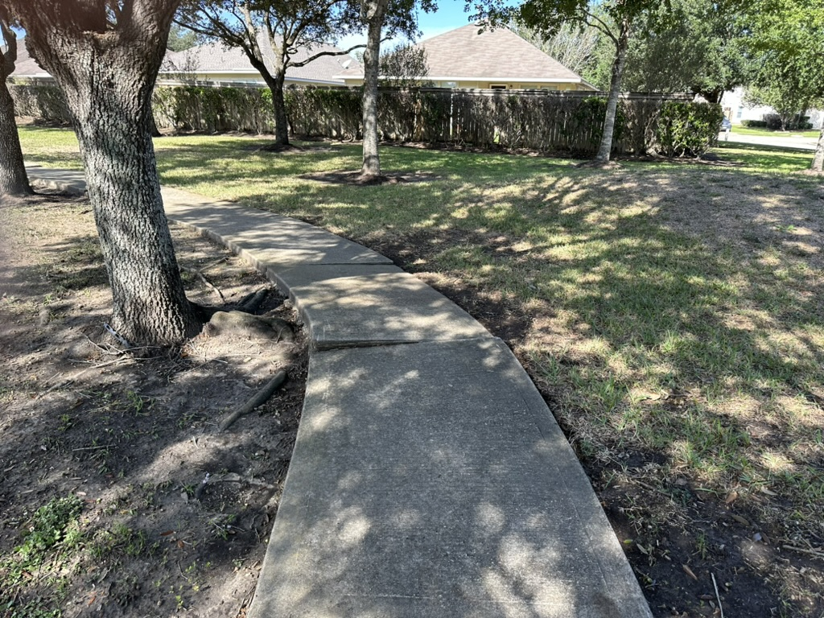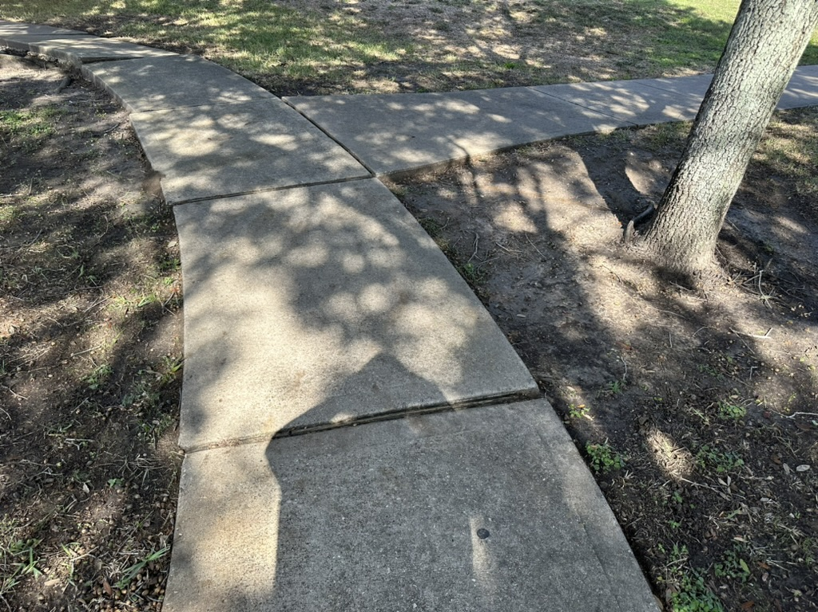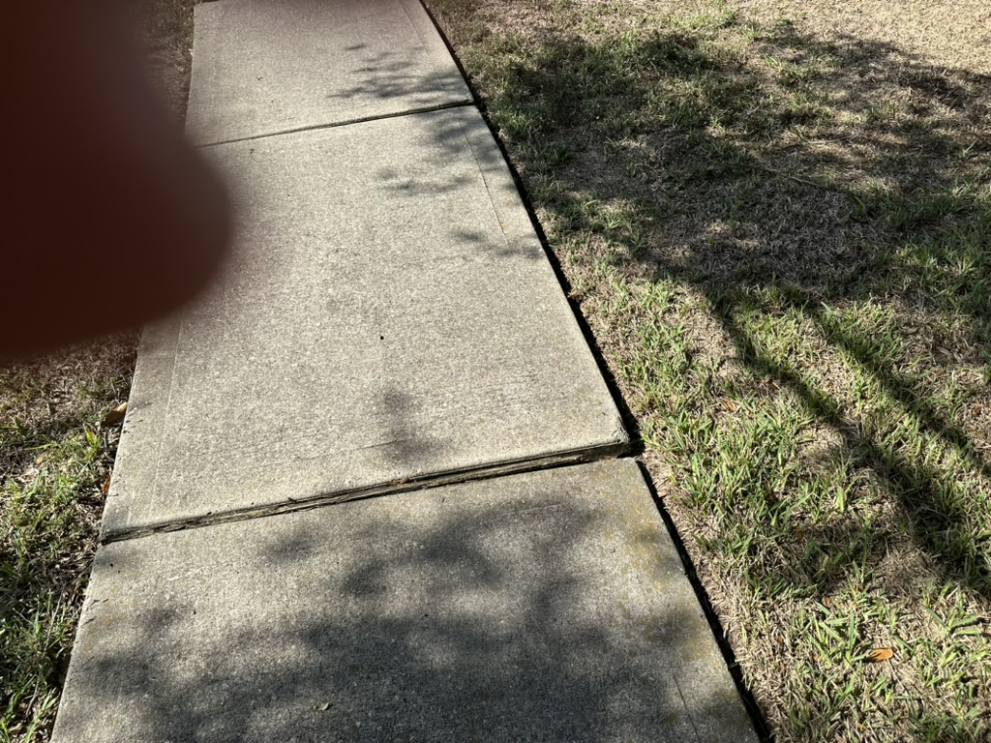

Reroute, remove replace?

Park #4, Harrowshire Lane

