`

REQUEST FOR

PROPOSAL

Upgrades to HOA Children's Parks

Issued: November 15, 2023

Responses Due: 9:00 AM CST, December 1, 2023

Issued by: Brunswick Meadows HOA Board of Directors

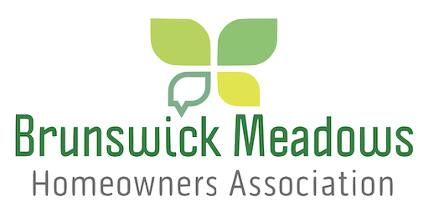

CONTACT:

Richard Tesmer

Treasurer

Richard.tesmer@brunswickmeadowshoa.com

(346) 543-2721
Table of Contents
1 Executive Summary 3
3 Administrative Information 4
3.1 Proposal Schedule / Key Dates 4
3.2 Proposal and Submission Requirements 4
3.3 Proposal Review Process 5
3.4 Contact Names 5
5 Project Overview 5
5.1 Community Need / Community Driver 5
6 Project Pricing / Payment Terms 6
7 Appendices / Other Material 6
8 Vendor Evaluation Factors 6

1 Executive Summary

Brunswick Meadows is a planned community started over 15 years ago, we, as the Board of Directors of the Homeowners Association, need a development vendor to provide services for upgrading our Children's Playground facilities. The Board is accepting proposals in response to this Request for Proposal (RFP) to find a qualified vendor to provide planning and construction services to upgrade the children's playgrounds.

Our goal is to:

- Reroute the sidewalk in the primary playground where a tree’s roots are uplifting the sidewalk and causing a trip hazard. This is a high-priority item.
- All the children's parks need the mulch replaced preferably with a rubberized mulch.
- Present a plan for replacing or upgrading the children's equipment, some of which are now 15 years old. You will need to review all the parks in the community. We will then prioritize which ones will be worked on first.
- As appropriate recommend covers over the children's equipment.
- As appropriate recommend additional benches and or picnic tables in the parks.

All prospective vendors must follow the established guidelines outlined in this proposal. Our objective is to locate a qualified vendor resource that will provide the best overall value for Brunswick Meadows. While price is a significant factor in a winning proposal, other factors will be considered to form the basis of our award decision. For additional information, please refer to the Evaluation Factors section of this RFP.

We respectfully request that vendors respond with an intent to bid or not to bid by no later than November 28, 2023, to management@brunswickmeadowshoa.com. Final submissions are due by Friday, December 1, 2023, 9:00 AM CST. For additional key dates, please review the Proposal Schedule/Key Dates section.

2 RFP Purpose

The purpose of this RFP is to locate a qualified partner to assist the HOA of Brunswick Meadows in implementing upgrades to the community children’s parks.

3 Administrative Information

3.1 Proposal Schedule / Key Dates

 | Item: |  |  | Date Due:
 | Release and Distribution of RFP |  |  | November 17, 2023
 | Date to Receive Bid/No Bid Responses |  |  | November 28, 2023
 | Deadline for Questions |  |  | November 28, 2023
 | Answers to Vendors’ Questions |  |  | November 30, 2023
 | Deadline for Submissions |  |  | December 1, 2023 9:00 AM CST
 | Date Finalists Will Be Notified |  |  | December 15, 2023
 | Date of Finalists Presentations |  |  | January 8, 2024
 | Date Winning Vendor(s) Will Be Selected |  |  | January 15, 2024
 | Date Unsuccessful Bidders Will Be Notified |  |  | January 15, 2024
 | Date Vendor Proposals Must Remain Active Until |  |  | April 30, 2024

3.2 Proposal and Submission Requirements

The following submission guidelines & requirements apply to this Request for Proposal:

- Only qualified individuals or firms with prior experience on projects such as the one outlined in this RFP should submit proposals in response to this Request for Proposal.

- Qualified vendors who intend to submit a proposal should notify the representative identified on the cover page no later than November 28, 2023.

- Vendors must list at least three projects that are substantially like this project as part of their response, including references for each. Examples of work should be provided as appropriate with images.

- Vendors must provide an overview of the proposed solution as well as resumes of all key personnel performing the work. In addition, the proposal should provide a proposed schedule and milestones, as applicable.

- Responses must be received on or before the submission due date of December 1, 2023, 9:00 AM CST. Any responses received after the scheduled due date will be considered invalid.

- Responses should be emailed to management@brunswickmeadowshoa.com and Richard.tesmer@brunswickmeadows.com.

- All sections of the RFP must be completed. If a section is not applicable, please state N/A in the section or indicate why you cannot answer the question.

- Electronic submissions must be signed and dated by a representative who is authorized to act on behalf of your company.

- Partners are expected to include copies of any licenses and insurance information.

3.3 Proposal Review Process

All responses will be reviewed by Brunswick Meadows Home Owners Association Board of Directors. Vendors may be required to answer additional questions to be selected.

3.4 Contact Names

Questions about this RFP may be directed to:

Richard Tesmer or Management

Treasurer

Richard.tesmer@brunswickmeadowshoa.com

(346) 543-2721

5 Project Overview

5.1 Community Need / Community Driver

Brunswick Meadows is made up of various sections, some of which are more than 15 years old and the youngest section being 8 years old. The children's playgrounds were created during those periods. The BOD would like to see proposals for upgrading and or replacing those parks with newer equipment and expansions to include more seating and covers over the equipment. The community includes two major parks and several minor parks, all are a part of the proposal. It is recommended that you drive the community, take pictures, and include line-item descriptions for all work. The Board may choose to do all recommendations or partial.

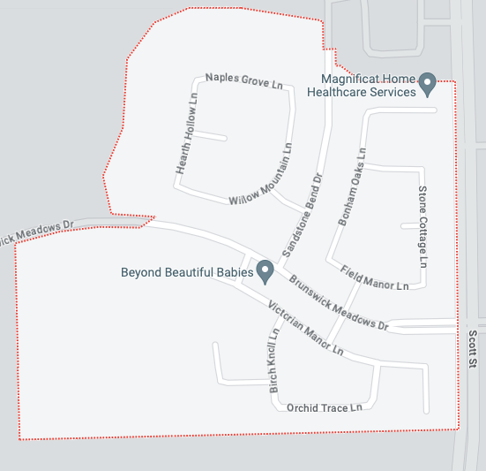

- Change Requests will not be accepted as this should be a Fixed Price Proposal from the vendor.

- You must provide copies of your insurance.

- Brunswick Meadows will not reimburse any costs associated with responding to this RFP, all such costs are solely the responsibility of the vendor.

6 Project Pricing / Payment Terms

This pricing proposal should indicate the overall fixed price for the project. Please include all warranty details.

If you have a standard set of terms and conditions, please submit them with your proposal. All terms and conditions will be subject to negotiation.

Please include your proposed payment schedule.

7 Appendices / Other Material

Please include the following as appendices to your proposal:

- Pricing Proposal

- Case Studies or Description of Similar Work Performed o Work Samples

o References from at least [TWO] companies where you performed work of a similar nature:
- First/Last Name, Company Name, email and phone number

- Any other information that you deem is appropriate for us to know as it relates to this

RFP

8 Vendor Evaluation Factors

The Board will rate proposals based on the following factors, with COST being the most important factor:

- Cost
- Responsiveness to the requirements outlined in this Request for Proposal
- Relevant past performance/experience
- Samples of work
- Technical expertise/experience of vendor and vendor’s staff

Brunswick Meadows HOA reserves the right to award the project to the vendor that presents the best value and solution as determined solely by the Board of Directors in its absolute discretion.

Brunswick Meadows HOA Board of Directors Representative:
Richard Tesmer
Richard.tesmer@brunswickmeadowshoa.com
(346) 543-2721

